Bo-taoshi
A micro dexterity game for 2 players in 10-15 minutes inspired by the Japanese sport of pole toppling

Components
5 discs – 2 blue, 2 red and 1 yellow
1 pole
1 ramp

Goal
The first player to knock over the pole with their airborne disc wins the game.

Setup
- Select play surface; ideally a smooth table or play mat 2-3’ per side
- Set the ramp aside within reach of both players
- Place the yellow disc in the center of the surface and then set the pole centered on top
- Players choose colors and collect their 2 matching discs; randomly determine player to go first

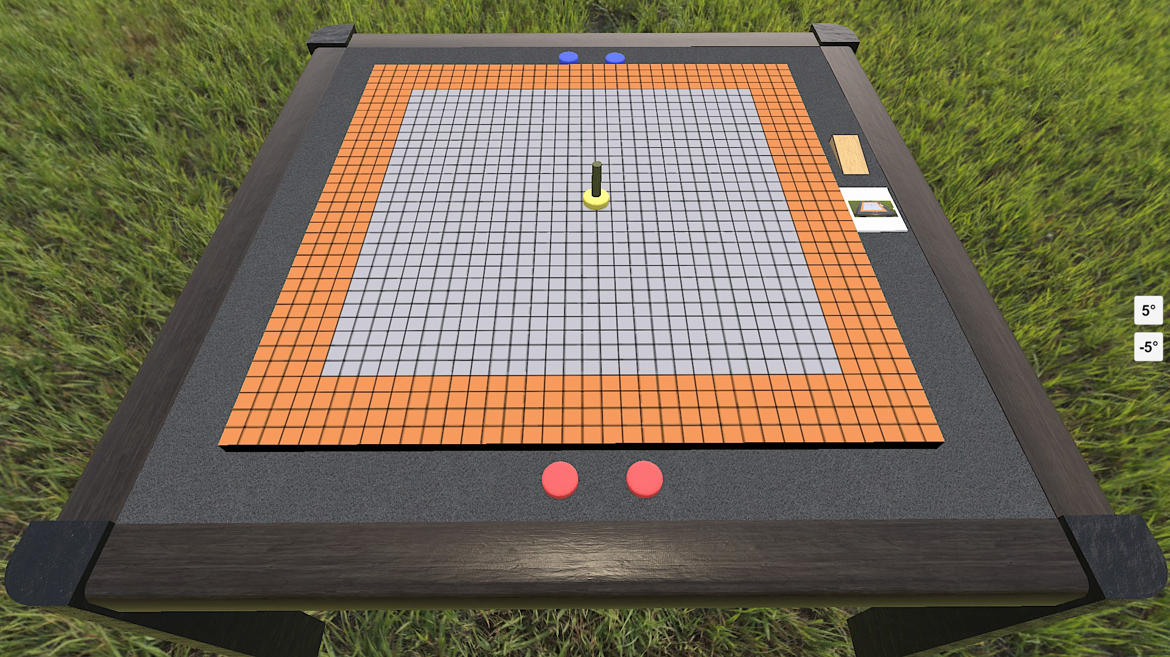

Infield vs Outfield
The play area is divided into 2 area: the infield and the outfield. Place either end of the ramp on the edge of the play area – the space along the ramp around the perimeter of the play area is the outfield; see orange area in the setup image above. The rest of the play area is the infield.

Game Play
Players take turns flicking 1 of their discs with following results:
- If the yellow disc is knocked completely into the outfield (or off the surface) the other player places it along the edge of the surface, flicks it back into the infield and places the pole on top
- Otherwise, if the pole is knocked over then put it back and the same player flicks their other disc – this is limited to once per turn
- Otherwise the player’s turn ends

Note: If either of the player’s discs are currently out of play, such as on their first 2 turns or if knocked out of play, then the player must place 1 on the edge of the surface and flick it into play.

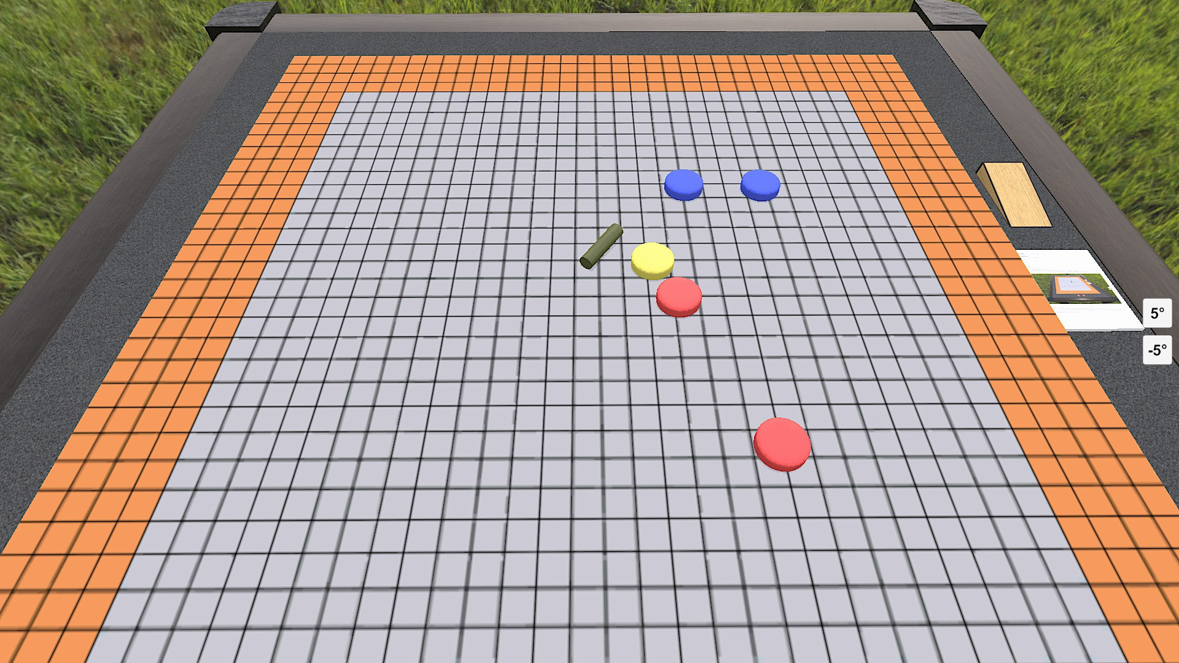

Ramp It!
If both of the player’s discs are in the infield they may use their flick to attempt to win the game:
- Place the ramp between their 2 discs so that the taller side of the ramp is against the disc closest to the yellow disc (see next page)
- The further disc is then flicked in an attempt to travel up the ramp and knock down the pole while airborne

Notes:
- The ramp must be able to fit between the player’s 2 discs such as the red player above
- If the flicked disc touches the table before striking the pole or the pole remains upright then both the flicked disc and the ramp are removed from the surface and the player’s turn ends

Example of a winning flick:

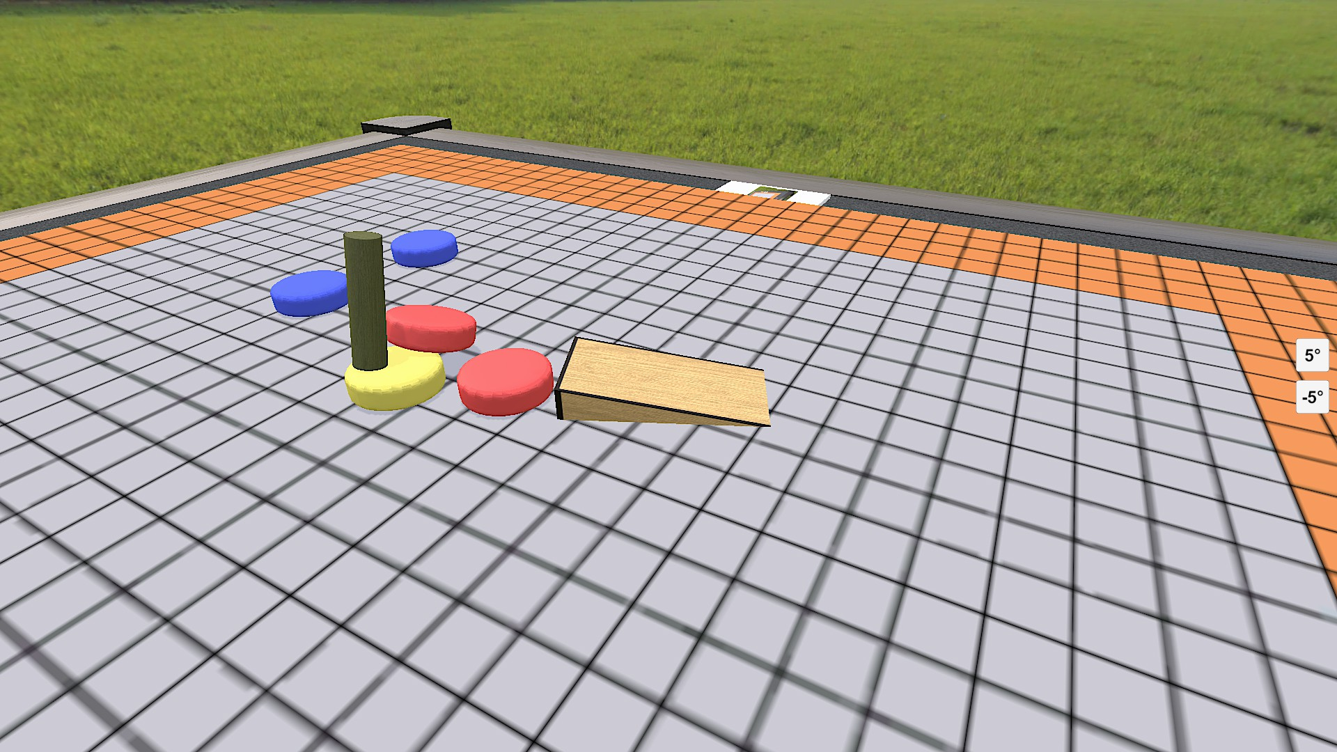

End of the Game
The first player to knock over the pole with their airborne disc wins the game.

Note: for a longer game players can play 3 or 5 rounds alternating taking the first turn with the player winning the most rounds being declared the overall winner.

Links
Discuss on Board Game Geek: https://boardgamegeek.com/thread/2492441
Play on Tabletop Simulator: https://steamcommunity.com/sharedfiles/filedetails/?id=2630958675
Follow along on Discord: https://discord.gg/3BxQSjpuny

